**Project Name: Zonions**

**Frontend Technologies:** React, HTML, CSS, Bootstrap, materialUI

**Backend Technologies:** MongoDB, Express, NodeJS

**1>Home Page:**

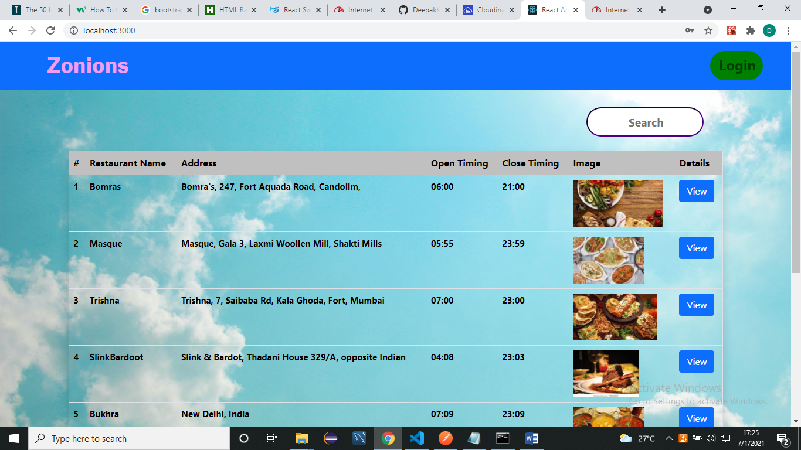

**2>Login Page:**

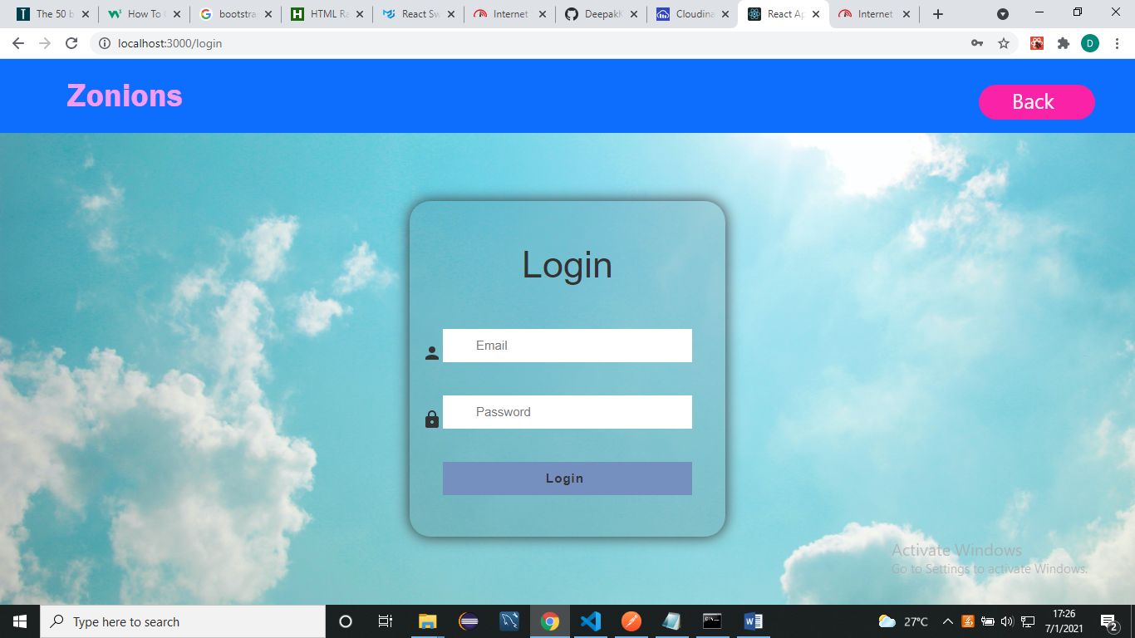

**3>Manage Restaurant Page:**

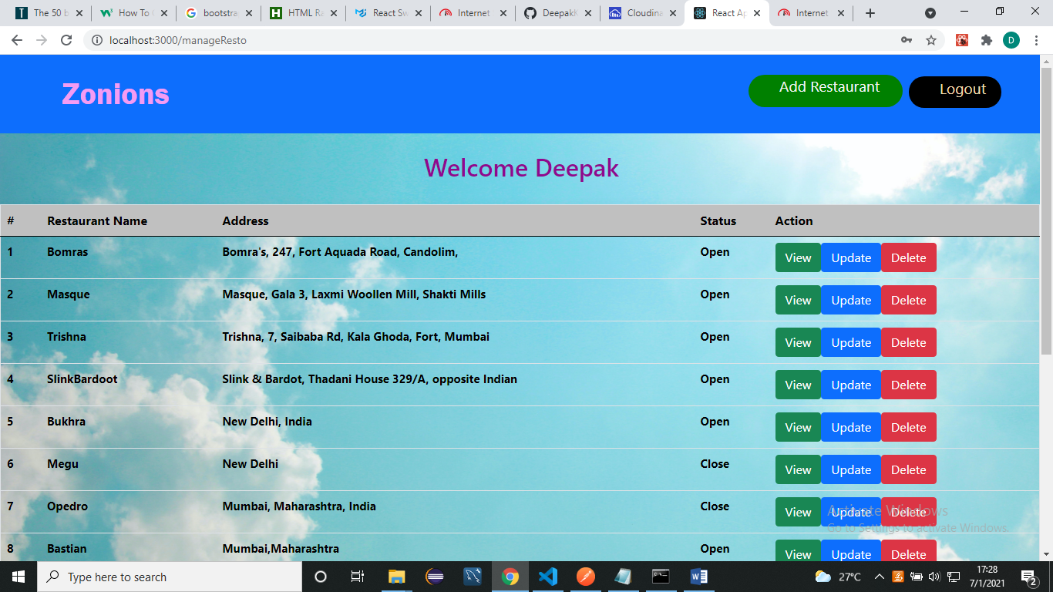

**4>Add Restaurant Page:**

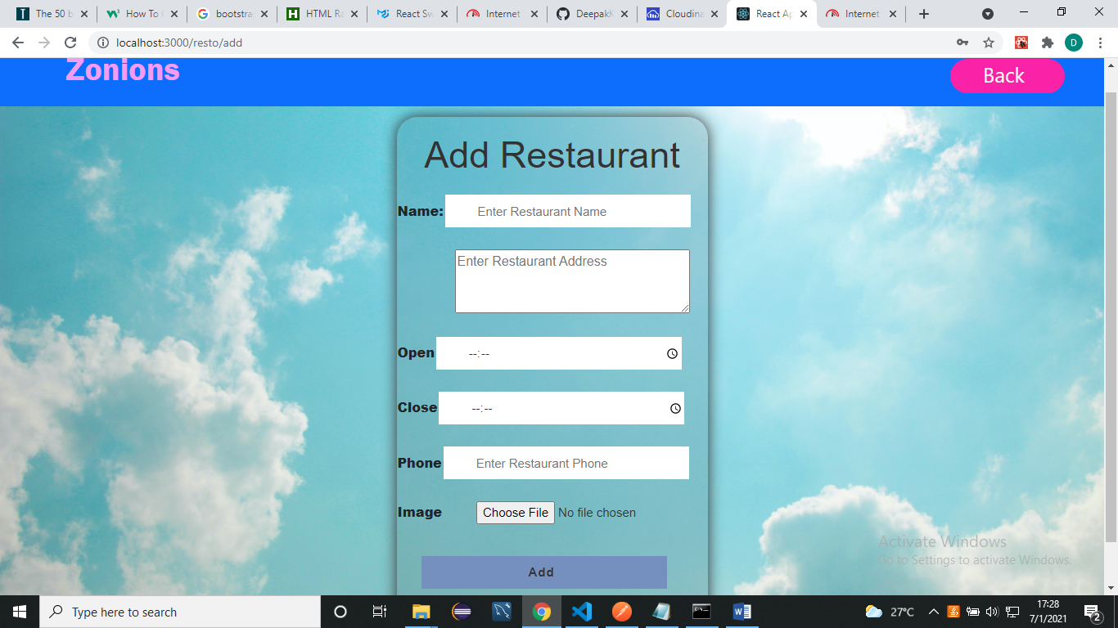

**5>Update Restaurant Page:**

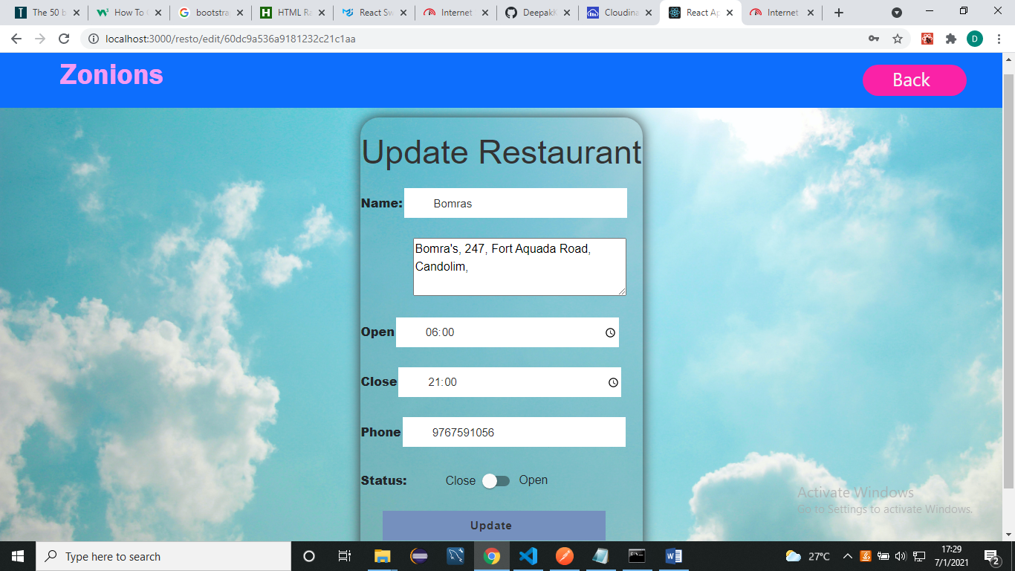

**View Restaurant Page:**

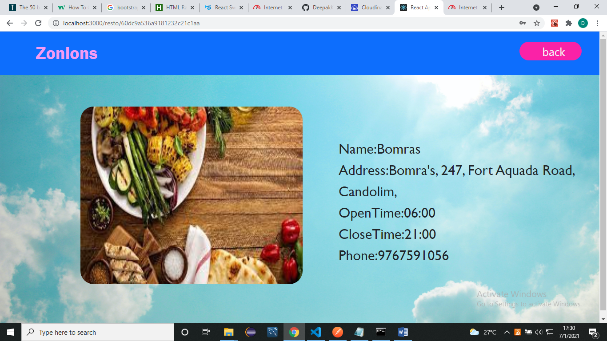

RESTApi’s:-

1>To get all restaurants: `http://localhost:5000/resto/allResto`(get request)

2>To get open restaurants: `http://localhost:5000/resto/` (get request)

3>To get specific Restaurant: `http://localhost:5000/resto/:id` (get request)

4>To add Restaurant: `http://localhost:5000/resto/` (post request)

5>To edit Restaurant: `http://localhost:5000/resto/:id` (patch request)

6>To delete Restaurant: `http://localhost:5000/resto/:id` (delete request)